**Sample Ethics Application**

Alphacrucis College – Human Research Ethics Committee

The following pages contain a sample ethics application. The pages show the questions that are

asked on the form and the responses show the sort of information that is required. Please look at this

form in conjunction with the document ‘Requirements for Ethics Application Forms’ which is

available on Moodle.

Please note that the Ethics Application Form may vary according to the nature of your project. If

you are doing research with participants under the age of 18 years, a section on Research with

Minors with appear. If you are doing research overseas, a section on Research Outside Australia

will appear. If all your participants will be aged 18 years or over and are living in Australia, these

sections will not appear.

Depending on the nature of your research, the Ethics Application Form may require that you submit

a number of documents from you, such as:

1. Permission letter to relevant organisations for doing research;

2. Advertising flyers for recruiting participants;

3. Agreement with assistant researchers who may see confidential data;

4. Information Sheet about the research;

5. Consent Form for participants to complete;

6. Surveys; and

7. Interview schedules.

You will see in this Sample Application Form references to such documents which have been

downloaded as part of the Application. These additional sample documents, as relevant to this

application, have been gathered and added as appendices. See the document ‘Requirements for

Ethics Application Forms’ for templates.

If you have any questions about filling in your Ethics Application Form, you may email me

[Secretary.HREC@ac.edu.au](mailto:Secretary.HREC@ac.edu.au). We are here to help you do your research ethically and fulfil the legal

requirements in so doing.

Philip Hughes,

Chair, Alphacrucis Ethics Committee.

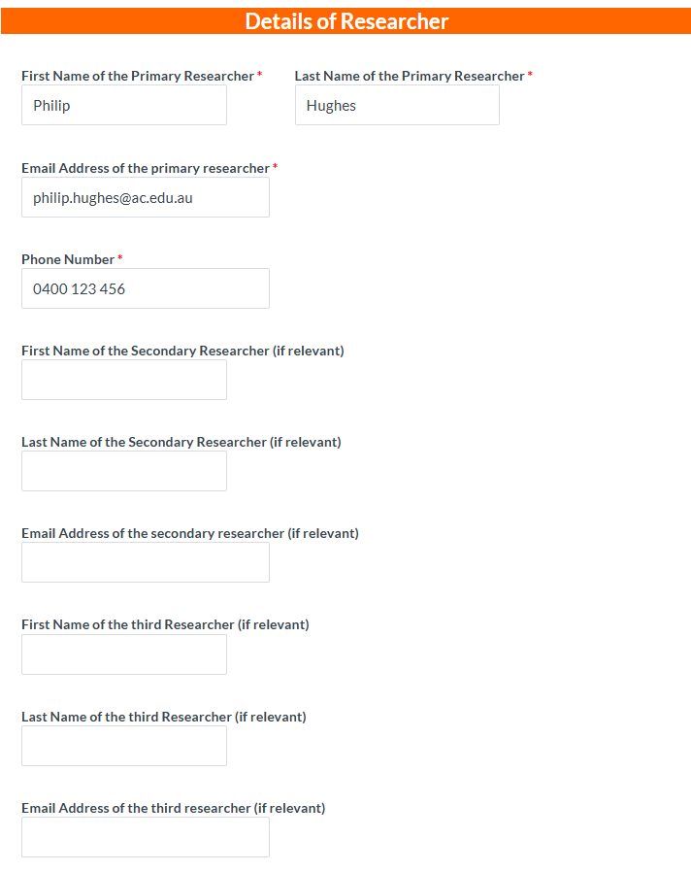

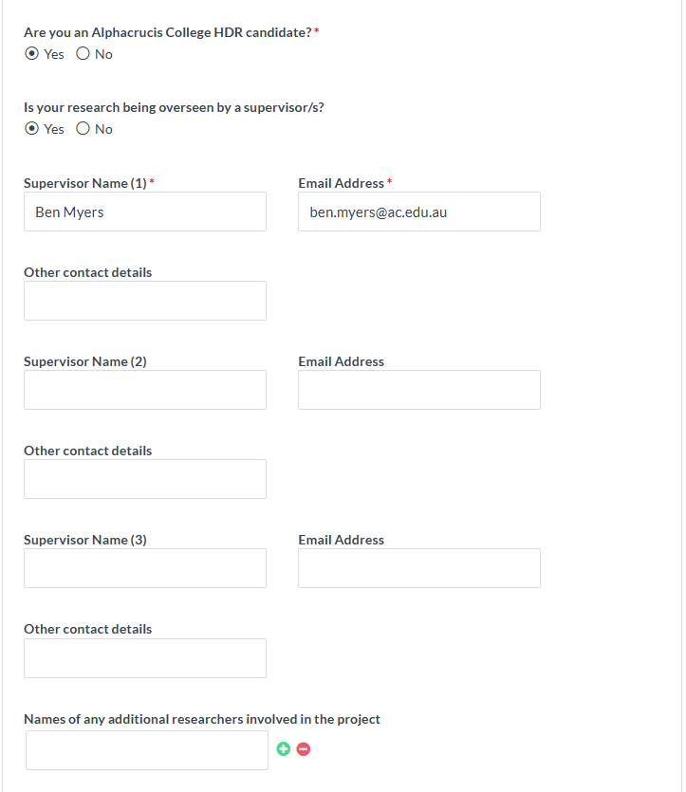

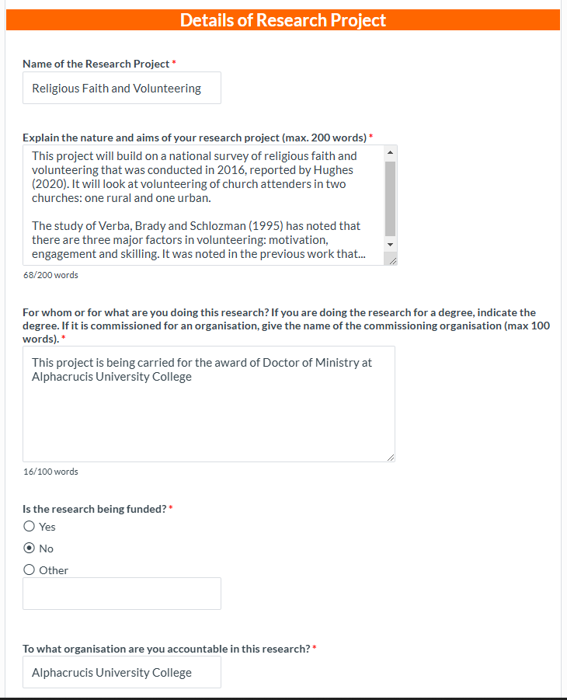

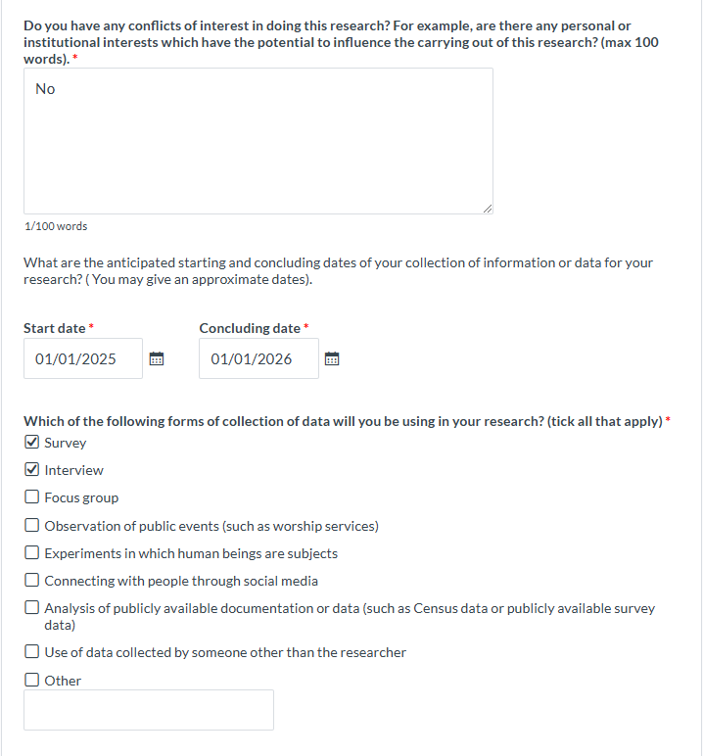

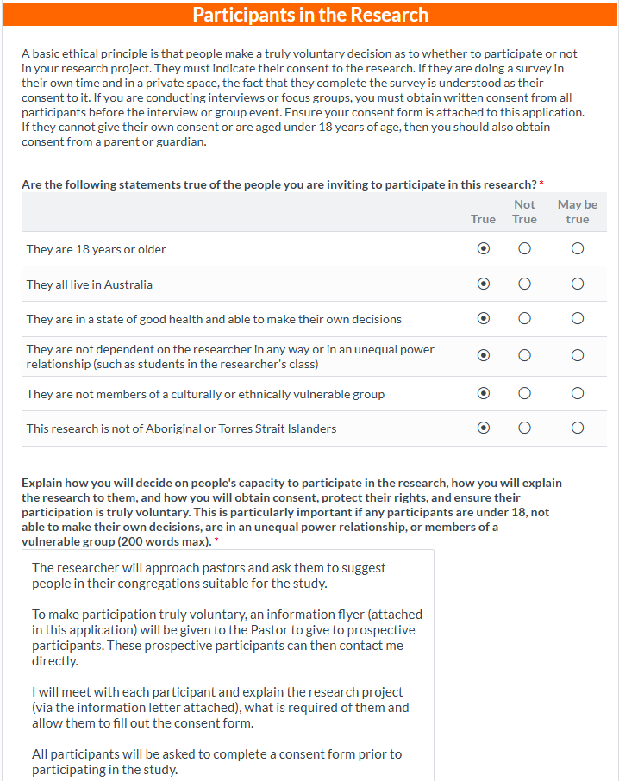

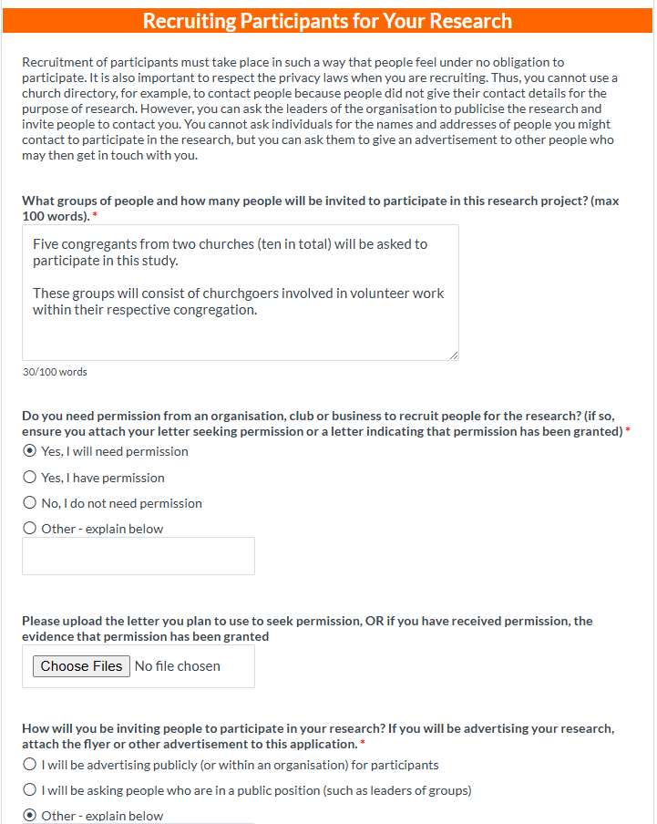

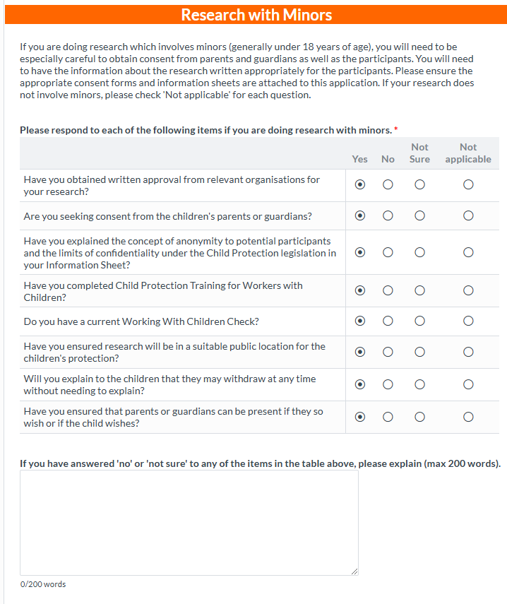

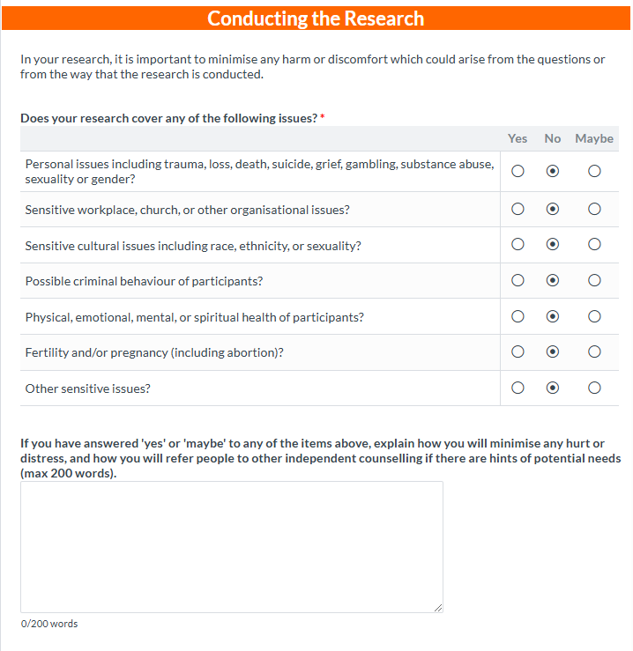

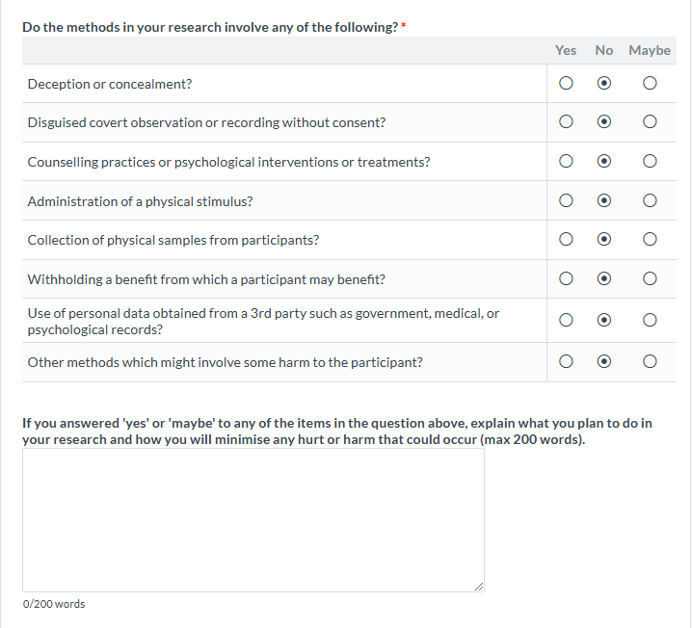

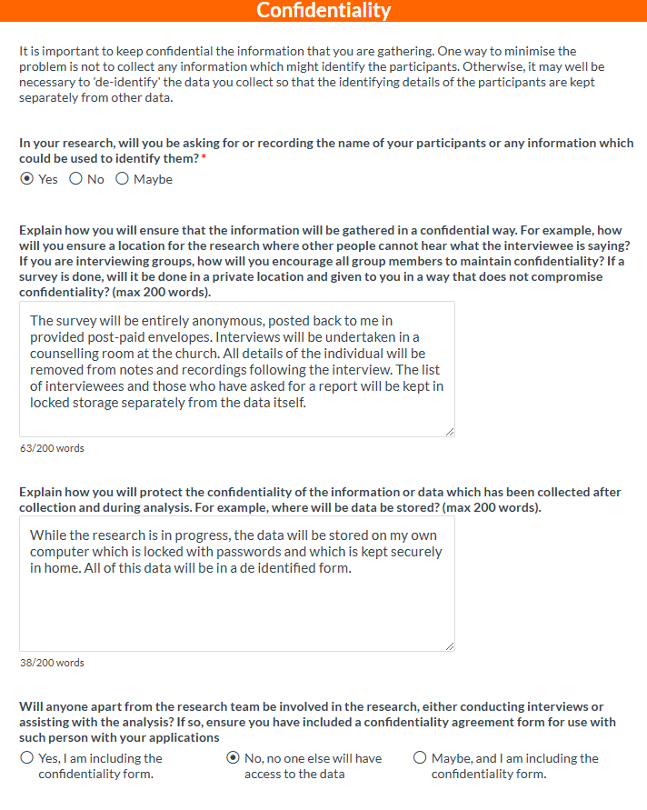

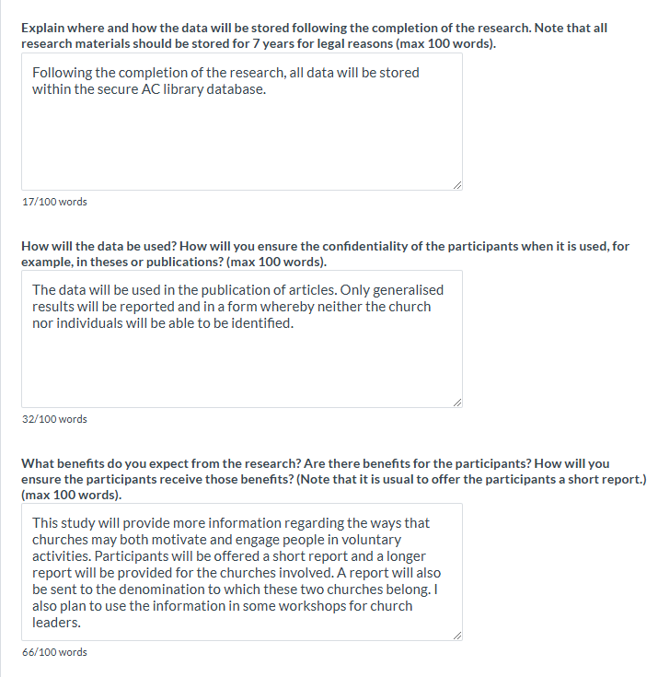

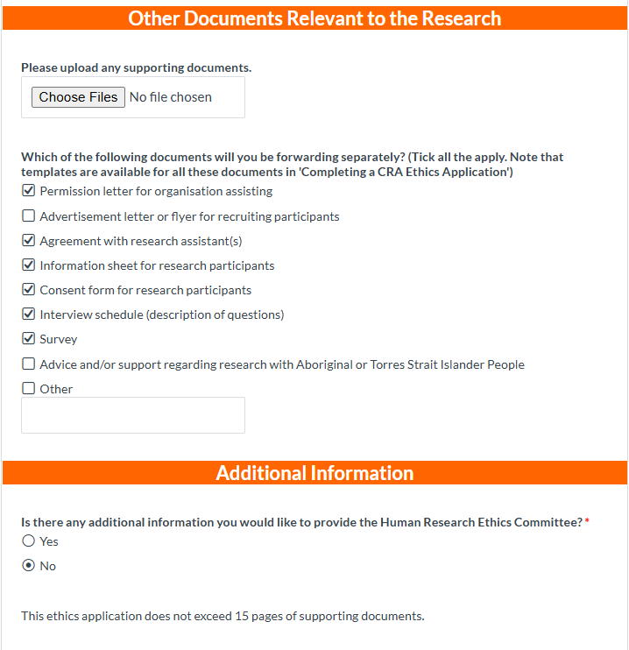

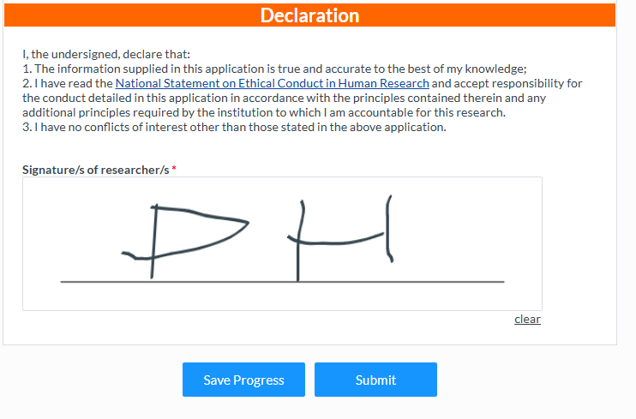

Philip Hughes

01.01.2025

John Brown, Chair of Church Council

Dear John Brown,

I am studying religious faith and volunteering at Alphacrucis as part of the requirements for a Doctorate of Ministry. This study is being supervised by Dr P Black.

The aims of the study are to understand the role of religious faith in motivating and engaging people

in volunteering. I expect the research to have benefits for both your church and the wider church in

providing direction as to how people can best be motivation and engaged in volunteering for the

benefit of the wider society and the church.

In order to undertake this research, I would be most grateful if you could invite people in your

church to participate in this research. Firstly, I would be most grateful if a short survey could be

distributed to all members of the congregation for them to complete in their own time. It will come

with a pre-paid postage envelope so they can post it back to me when they have completed it. I will

also be seeking people who could do an interview with me in which I can explore in greater depth

the nature of their volunteering, their motivations and the forms of engagement that were

significant for them. Would it be possible for me to hold these interviews in the church counselling

room?

All information gathered from participants will kept confidentially. While it must be kept for 7 years

for legal reasons, it will be kept in locked cupboards at Alphacrucis. Only general patterns from this

research will be reported in my thesis and in any other articles or publications based on this

research.

In return for your assistance, I am happy to offer you a short report of the outcomes of the research.

I will also offer a short report to all who participate in the research.

I am happy to provide further information on the research, and you may contact me on [Philip.hughes@ac.edu.au](mailto:Philip.hughes@ac.edu.au).The research will be approved by the Human Research Ethics Committee at Alphacrucis

and any ethical concerns regarding this research may be addressed to [secretary.HREC@ac.edu.au](mailto:secretary.HREC@ac.edu.au).

Please let me know if you are willing to assist me in the research and I will then be in touch to make

practical arrangements.

Yours sincerely,

Philip Hughes

**Information Sheet**

Religious Faith and Volunteering among Church Attenders

I am studying religious faith and volunteering at Alphacrucis as part of the requirements for the Doctorate of

Ministry. This study is being supervised by Dr P. Black.

The aims of the study are to understand the role of religious faith in motivating and engaging people in

volunteering. I expect the research to have benefits for both your church and the wider church in providing

direction as to how people can best be motivation and engaged in volunteering for the benefit of the wider

society and the church.

In order to undertake this research, I would be most grateful if you would be willing to participate in this

research. Please note that participation is entirely voluntary and there are no consequences for you of not

participating. Participants will be asked firstly to complete a short survey which will be distributed at church

services from 1st March. You may complete this in your own time at home and post it back to me in the

postage paid envelope provided.

I am also looking for people who would be willing to be interviewed about their voluntary activities. This

should not take longer than 30 minutes, but it will allow me to understand your volunteering at greater depth:

what has motivated you and sustained you in your activities. There are no costs to being involved. However,

you involvement in this way will help the churches in motivating and engaging other people in volunteering.

I would like to record the interview for the purposes of analysis. Please let me know if you are willing for this to

occur on the consent form. If you would prefer that I did not record the interview, that is fine. I will rely on the

notes that I take. If, at any time, you do not wish to answer a question, you can simply say 'Pass' and we will

move on. It is not anticipated that you will find any of the questions sensitive or difficult to answer. There are

no right or wrong answers. I am simply interested in your thoughts: your experiences, insights and your

opinions. If you wish to withdraw your participation, you may do so up by simply letting me know up to 2

weeks after the interview.

All information gathered from participants will kept confidentially. While it must be kept for 7 years for legal

reasons, it will be kept in locked cupboards at Alphacrucis. Only general patterns from this research will be

reported in my thesis and in any other articles or publications based on this research.

In return for your assistance, I am happy to offer you a short report of the outcomes of the research.

I am happy to provide further information on the research, and you may contact me on [Philip.hughes@ac.edu.au](mailto:Philip.hughes@ac.edu.au). The research will be approved by the Human Research Ethics Committee at Alphacrucis and any ethical

concerns regarding this research may be addressed to [secretary.HREC@ac.edu.au](mailto:secretary.HREC@ac.edu.au).

Please complete the Consent Form if you are willing to assist me in the research and I will then be in touch to

make practical arrangements.

Yours sincerely,

Philip Hughes

**Consent of Research Participants**

**Project: Religious Faith and Volunteering**

**Researcher: Philip Hughes.**

I (*the participant*) understand what this research project is designed to explore. What I will be asked

to do has been explained to me. I agree to take part in the project, realising that I can withdraw at

any time without having to give a reason for my decision. I agree that research data collected in the

study may be published in a form that does not identify me in any way.

I am willing / not willing for the researcher to make an audio recording of the interview or focus

group. (Please indicate if you are willing OR not willing.)

I am happy for the researcher to contact me to arrange a suitable time and place for a conversation.

NAME OF PARTICIPANT …......................................................................................................

SIGNATURE ................................................................. DATE .................................……....

CONTACT DETAILS: Email contact: ..............................................................

Telephone (if needed to arrange the conversation): ............................................

*[Include the following section if appropriate.]*

*If you are under the age of 18, please also ask your parent to sign their consent to the conversation.*

Parent's confirmation

I confirm that I……………….....……............................................................................ (the child's parent/guardian) have provided written consent for………………….…...……………………………………………………………………(child's name) to take part in the research and that I have explained the information provided above to my child and that he/she has indicated that he/she understands the activity and wants to participate.

SIGNATURE ….........…………………………………….(parent/guardian) DATE …………………........

*Please hand this form to <name of person> or post it to <address of researcher>.*

## Agreement with Research Assistants Regarding Confidentiality and Intellectual Property

Name of Project: **Religious Faith and Volunteering**

We thank you for your willingness to assist in this project. In doing so, it is important that

you keep the confidentiality of all the information that has been gathered in the course of

the project. Hence, we ask that you sign your agreement to following points.

**Confidentiality**

The research assistant must not during the term of their involvement or anytime

afterward (except in the proper course of their duties or as may be required by law):-

1. Without prior consent of Alphacrucis College copy any document or disclose to any

other party any confidential information or material relating to the research

project;

2. Use or attempt to use any information gained in the process of the research and

data gathering in any manner outside of this research project;

3. At the end of the research project, returned to the [name of the researcher], who

will arrange for a copy to be kept at Alphacrucis for the required time of 7 years,

while all other copies are destroyed;

4. Will not keep in electronic or hard copy any material or notes relating to this

research once the files have been sent to [the name of the researcher].

**Copyright and Intellectual Property**

In signing this form, [name of the research assistant] forfeits any rights to intellectual

property that the member may have developed at the direction of [name of the

Alphacrucis researcher] whilst in any capacity of research data gathering.

*“I ……………………………………………………… both acknowledge and agree to abide by the terms and*

*conditions of my responsibilities towards confidentiality and intellectual property during my*

*involvement with any and all aspects of the research project of [name of researcher].”*

Name of research assistant: ……………………………………………………………………………………..

Signature of research assistant: ………………………………………………………………………………..

Date of signing: …………………………………………….

**Introduction to Survey**

**Introduction to Survey**

I am studying religious faith and volunteering at Alphacrucis as part of the requirements for

Doctorate of Ministry. This study is being supervised by Dr P. Black.

The aims of the study are to understand the role of religious faith in motivating and engaging people

in volunteering. I expect the research to have benefits for both your church and the wider church in

providing direction as to how people can best be motivation and engaged in volunteering for the

benefit of the wider society and the church.

In order to undertake this research, I would be most grateful if you would be willing to complete this

survey. Please note that participation is entirely voluntary and there are no consequences for you of

not responding to the survey. You are also free to refrain from answering any question. The survey is

likely to take you about 10 minutes

There are no right or wrong answers. I am simply interested in your thoughts: your insights and your

opinions. All information gathered from participants will kept confidentially. While it must be kept

for 7 years for legal reasons, it will be kept in locked cupboards at Alphacrucis. Only general patterns

from this research will be reported in my thesis and in any other articles or publications based on

this research. I will not be asking your name or identifying details in the survey.

In return for your assistance, I am happy to offer you a short report of the outcomes of the research.

You may contact me to request a report or to obtain further information about this research on

[Philip.hughes@ac.edu.au](mailto:Philip.hughes@ac.edu.au). The research will be approved by the Human Research Ethics Committee at

Alphacrucis and any ethical concerns regarding this research may be addressed to

secretary.HREC@ac.edu.au.

Please note that your willingness to participate in the research is indicated by your completion of

this survey.

[Name of researcher]

**Survey Questions**

**Informal Volunteering**

*One way many people contribute to the lives of others is through the care of people in their*

*families and their neighbourhood.*

1. Which statement best describes your household? You live ...

* Alone
* As a single parent living with children
* With a partner/spouse and children
* With a partner/spouse without children
* With a variety of family members
* With other adults not related to me
* With parents, with or without other brothers or sisters
* Other (please describe) ________________________________________

2. Over the past 12 months, have you done any of the following, outside of your paid

employment?

*(Please click on all that apply or leave blank if none apply.)*

That are members of your family, including your extended family and people who are not members of

your family.

* Cared for a person who is sick or who has a disability
* Cared for babies or children (other than your own children)
* Cared for an elderly person
* Provided financial or other support for children who are not living with you

3. On average, how many hours per month do you estimate you have spent in the physical

care of babies or children (other than your own), or sick, disabled or elderly people, outside

your paid employment? *(Enter '0' if you have not spent any hours in such activities.)*

____ Hours per month

4. Over the last 12 months, did you provide any help without pay for others in the following

ways? *(Please click on all that apply or leave blank if none apply.)*

* Domestic work, home maintenance or gardening
* Providing transport or running errands
* Teaching, coaching or practical advice
* Providing emotional support
* Use of your specialised or professional skills to help others
* Other

5. If you clicked 'other' in question 4, please describe how you provided help.

___________________________________________

___________________________________________

___________________________________________

6. On average, how many hours per month do you estimate you have spent without pay

helping people in such was as described in questions 11 and 12? *(Enter '0' if you have not*

*spent any hours in such activities.)*

____ Hours per month

**Unpaid Work**

*The next few questions are about unpaid voluntary work, that is, help willingly given in the*

*form of time, service or skills to a club, organisation or association.*

7. Here are examples of the types of organisations or groups for which people may do

voluntary work. In the past 12 months, did you do ***unpaid voluntary work*** for any of

these types of organisations? *(Click all that apply or leave blank if none apply.)*

* Arts, music or drama (other than as a performer)
* Parenting, children or youth
* Welfare or community services
* Ethnic or cultural organisations
* Business, professional or union organisations
* Education and training (such as schools, U3A)
* Emergency services
* Environmental or animal welfare (including landcare)
* Exercise or health (including gyms, hospitals, infant welfare)
* International aid and development
* Political, law or justice organisations
* Religious organisations (including churches)
* Sport and physical recreation
* Other recreational or personal interest groups
* Other (please describe) ________________________________________

8. On average, how many hours per month do you estimate you have spent doing unpaid work for the

sorts of groups in question 13? *(If you have not been involved in such groups, type '0'.)*

____ Hours per month

9. What sort of activities did the unpaid work ***mostly*** involve? *(Please choose just one*

*option.)*

* Mostly work that required professional expertise (such as required in teaching or
* providing professional advice)
* Mostly work that involved trade skills (such as being treasurer of an organisation or
* working in emergency services)
* Mostly work that did not require special skills (such as delivering leaflets or sales)
* Other (please describe) ________________________________________
* Not applicable to me

10. On average, how many hours per month do you estimate you have spent doing unpaid work for

religious organisations? *(Leave blank if you have not done any unpaid work for a religious*

*organisation.)*

____ Hours per month

11. What proportion of the work you did for the religious organisation was for the benefit of

the wider community, such as providing material help for people in need or running a play

group for the wider community? Please exclude time spent with the intention of teaching

others about religious beliefs and practices. *(We want to distinguish this sort of work from*

*activities for the religious organisation, such as leading in worship services or organising social*

*activities for the members.)*

* *0% None for wider community*
* *10%*
* *20%*
* *30%*
* *40%*
* *50% Some for wider community*
* *60%*
* *70%*
* *80%*
* *90%*
* *100% All for wider community*
* *Don't know / Not relevant*

12. How important are each of the following reasons or motivations for doing this unpaid

work?

|  |  |  |  |  |  |  |  |  |  |  |  |
| --- | --- | --- | --- | --- | --- | --- | --- | --- | --- | --- | --- |
|  | 1 Not  important | 2 | 3 | 4 | 5 | 6 | 7 | 8 | 9 | 10 Very  important | Not  applicable |
| You enjoy it |  |  |  |  |  |  |  |  |  |  |  |
| You enjoy  meeting people |  |  |  |  |  |  |  |  |  |  |  |
| You gain skills |  |  |  |  |  |  |  |  |  |  |  |
| You live out  your values |  |  |  |  |  |  |  |  |  |  |  |
| You know people will benefit from  what you do |  |  |  |  |  |  |  |  |  |  |  |

**Interview Schedule**

I am studying religious faith and volunteering at Alphacrucis as part of the requirements for

Doctorate of Ministry. This study is being supervised by Dr P. Black. As I indicated in the Information

Sheet, the aims of the study are to understand the role of religious faith in motivating and engaging

people in volunteering. I expect the research to have benefits for both your church and the wider

church in providing direction as to how people can best be motivation and engaged in volunteering

for the benefit of the wider society and the church.

This interview should take about 30 minutes. Are you okay with that?

There are no right or wrong answers. I am simply interested in your thoughts: your insights and your

opinions. All information gathered from participants will kept confidentially. However, if you do not

want to answer a question, you may choose to just say 'Pass' and we will move on. You do not need

to give any reason for not answering.

And if you decide that, after the interview, you would rather withdraw your participation, send me

an email and I will delete all the information you have provided. I can do that in the next two weeks,

but after that it will not be possible to separate from the other data what you have provided.

Only general patterns from this research will be reported in my thesis and in any other articles or

publications based on this research. I will not be identifying you in anything that is published.

In return for your assistance, I am happy to offer you a short report of the outcomes of the research.

Would you like a report?

Firstly, are you happy for me to record this interview?

1. Tell me about the groups with which you have been volunteering over the past 12

months? What sort of volunteering have you done? What roles have you played in those

groups?

2. How did you become involved in those groups? Did you have friends who were involved?

How did you hear about the groups?

3. What first motivated you to become involved?

4. Have there been times when you have thought of giving up or reducing your

involvement?

5. What has sustained you in your volunteering?

6. Do you think your religious faith has played a role in motivating you? How?

7. Have you received any encouragement from people within the church?

8. Who else has given you encouragement and support? Your family, for example?

9. How long do you think you will continue to be involved?

10. Are there other forms of volunteering you would like to give a go?